**Class Activity: RecyclerView**

1. Many Tasks!

In this activity, we will be making use of the RecyclerView. We will be creating a scrollable task list where users can add items into the list.

First, create a layout where the user can input the task and have a “Add” button. Then display the task list using a RecyclerView.

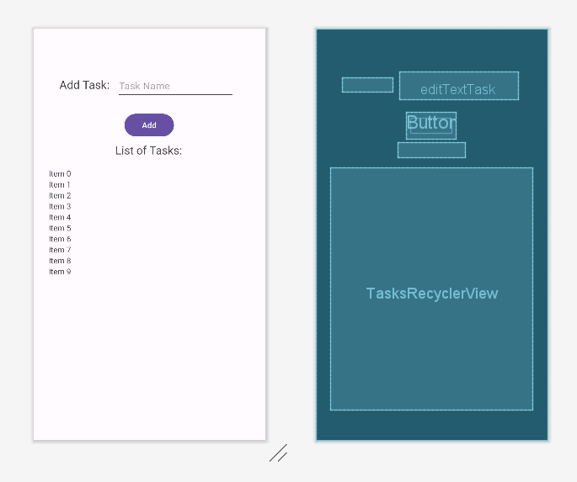

Remember to create the ViewHolder to hold the data, as well.

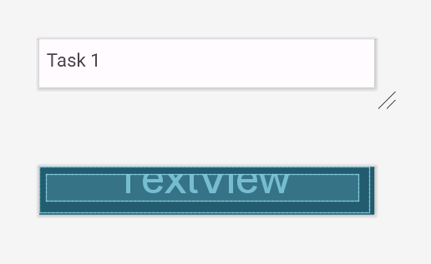

In the main activity and adapter, instead of making use a “String []” array, we will make use of an “ArrayList<String>” instead. This will allow us to easily add task into the Array List. When the user inputs a task and clicks on “Add”, it will be added into the Array List and the RecyclerView should be updated. Follow the steps in the slides to build your RecyclerView components.

*Challenge: Figure out how to update the data in the RecyclerView.*

**Expected output:**

